React Famous useful Libraries Packages

* ClassNames
* Framer-Motion
* Styled Component
* React-joi

Extension

React.js developer tools extension in chrome

# Extensions:

# React Developer Tools

* Thunder Client ( Alternative of Postman)
* Auto Rename Tag(Msln humny ek tag banaya <h1> </h1> tu ab agr hum opening tag ko <h1> sa <h2> krain gat tu closing tag automatically </h2> ho jay gay ani hamain manually khud nahi krna pry ga.
* Live Server
* Prettier(Coder formatter)
* Reactjs code snippets (i.e ek file banao aur type kro rfc aur enter tu file ka nam sa functional component ban jay ga aur export line bhi likhi ayy gi).

**Useful Tricks**

1. How to use state variable as ClassName?

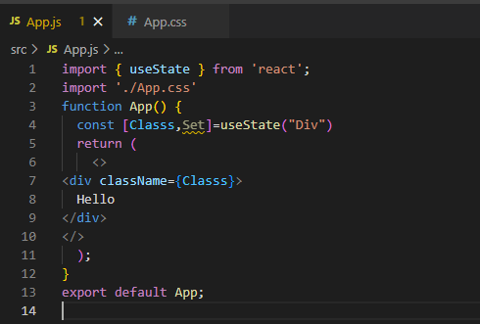 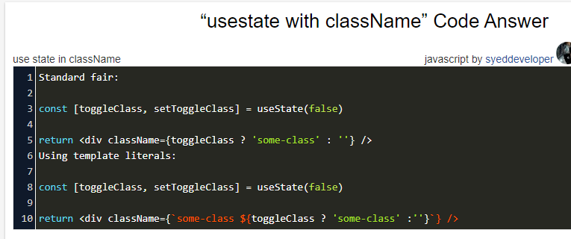

**Useful Error Solutions**

1.My Image is not loading

Solution: Just put your image folder in public folder and then you can use any of the following syntax,as it will work because image folder is now in src folder.

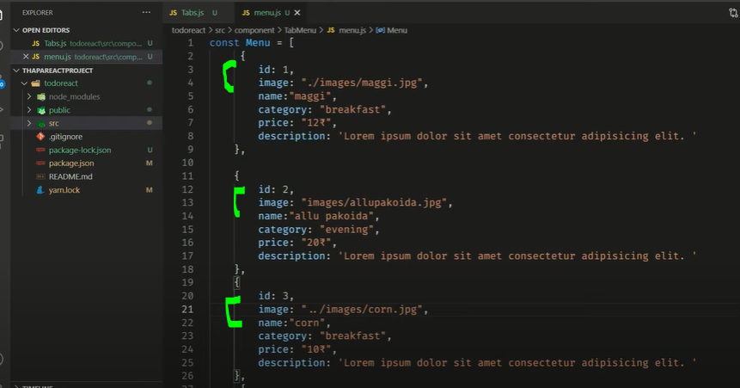

# 2. [React js: Error: useLocation() may be used only in the context of a <Router> component](https://stackoverflow.com/questions/66747556/react-js-error-uselocation-may-be-used-only-in-the-context-of-a-router-com)

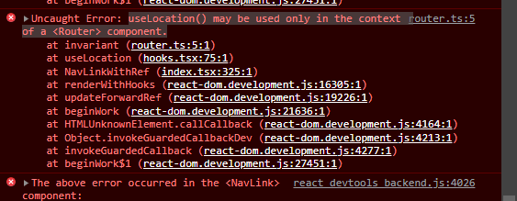

Solution: <https://stackoverflow.com/questions/66747556/react-js-error-uselocation-may-be-used-only-in-the-context-of-a-router-com>

|  |  |
| --- | --- |
| Error | Solution |

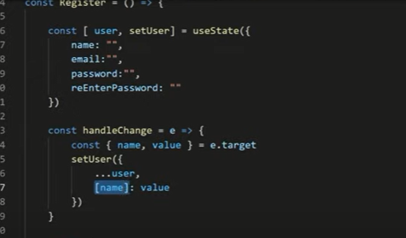

* npm init krny sa ye hamary node package
* **BrowserRouter** vs **HashRouter** :

The **BrowserRouter** is used for applications which have a dynamic server that knows how to handle any type of URL whereas the **HashRouter** is used for static websites with a server that only responds to requests for files that it knows about.

**Sidebar damping movement**

Jo sidebar ha wo uchal kr yani move kry ga yani ziada axha feel ayy ga damping

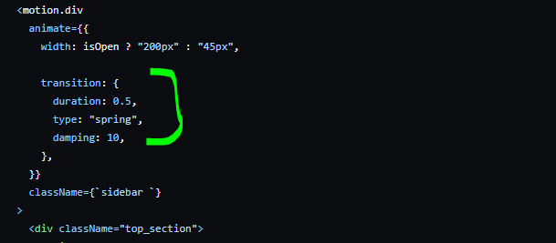

**Important error regarding map()**

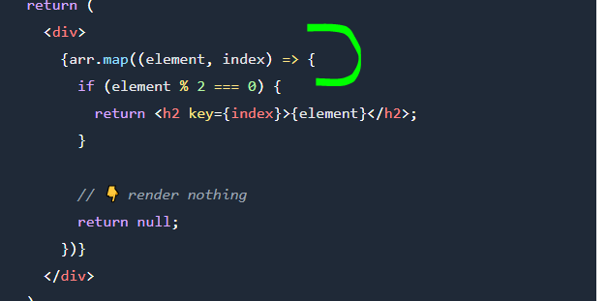

Jb hum map ma {} lagaty hain tu hamain explicityly return likhna prta ha agr hum return nhi likhain ga aisy hi sb likh dain ga tu output show nhi ho gi.Lekin agr hum {} ki bajay () lagaien tu hamain explicitly return ki zarort ni